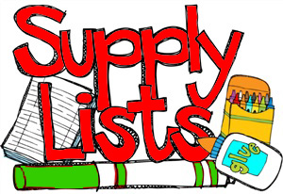
First/Second Grade Supply List
Please send the following items with your child on the first day of school. Please label all items, except those listed for classroom use, with your child’s name.
Thank you,
Mrs. Aguilar

- 1 Backpack (school appropriate)
- 1 small pencil box
- Crayola colored pencils (12 to 24 count)
- 24 pack Crayola Crayons
- 1 package of washable markers
- 8 gluesticks
- 1 bottle Elmers glue
- 24 count pencils (pre-sharpened Ticonderoga #2 pencils preferred)
- 1 pair student scissors
- 1 package of assorted colored highlighters
- 2 dry erase markers
- 1 small white board (no bigger than 9”x12”)
- 2 erasers
- 1 clipboard (Low profile so it can fit inside a desk. You can find these at Dollar Tree.)
- 16 count watercolor set
- 1 pair of small inexpensive headphones or earbuds (Please place these in a plastic bag with your child’s name)
- 1 pair of children’s gardening gloves

Classroom Use Supplies:
- 1 box bandaids
- 1 canisters of clorox wipes
- 2 boxes of tissue

